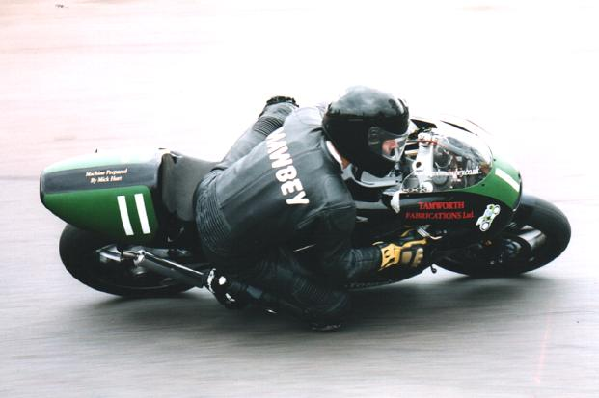

DATE | VENUE | CIRCUIT | RESULTS | LAP TIME
March 22nd - 23rd | Snetterton | Map | 13th, 10th & 16th | 1:15.03
March 30th | Darley Moor | Map | 18th, 2nd, 15th & 2nd | 1:00.97
April 6th | Mallory Park | Map | 3rd, 3rd & 12th | 0:58.04
April 19th - 21st | Oulton Park | Map | 11th DNF & 15th | 1:53.51
May 10th - 11th | Cadwell Park | Map | 10th, 12th & 11th | 1:34.45
May 25th - 26th | Brands Hatch | Map | 27th, DNF & 23rd | 0:52.05
June 14th - 15th (Club circuit) | Cadwell Park | Map | 2nd, 3rd & 11th | 1:04.91
June 28th - 29th | Darley Moor | Map | 3rd, 2nd, 2nd & 3rd | 1:00.60
July 6th | Mallory Park | Map | 3rd, 1st, 9th 1st | 0:57.01
July 26th - 27th | Darley Moor | Map | 1st, 7th, 2nd, DNF | 0.59.84
August 2nd - 3rd | Brands Hatch | Map | 7th, 7th & 19th | 0.51.25
August 25th | Darley Moor | Map | 2nd, 9th & DNF | 1:00.33
September 7th | Mallory Park | Map | 4th, 2nd, 11th & 1st | 0.58.02
September 14th | Darley Moor | Map | 2nd, 8th, 2nd & 8th | 1:00.60
October 4th - 5th | Darley Moor | Map | DNF & 1st | 1:01.02
DATE | VENUE |  | ORGANISING CLUB
October 26th | Mallory Park | Map | Phoenix

